What is Chatter Pix Kids?
Chatter Pix Kids is an iPhone/iPad app. After importing or taking a photo within the app, students draw a line for a mouth. This app allows students to add voice to their photo by recording 30 seconds of audio. This app features the ability to import a photo, add audio, apply a filter, add text, and export the video to the camera roll.
Teachers will learn how to use the Chatter Pix Kids App as a tool to allow students to create products that are integrated into the curriculum.
Download the Chatter Pix Kids App from iTunes
ChatterPix Kids

Uses in the Classroom Chatter Pix Kids can be used as an independent or partner activity in a center to produce a technology integrated product like a book response, story elements, personification, retell/summary, point of view, autobiography, biography, explain your thinking, answer a question, facts, opinions, present research, tell a 30 second story.
Links to Chatter Pix Kids Examples available on YouTube
Problem in a story from the point of view of a character
Problem from the point of view of a character 2
Sea Animal Facts
Measuring
1st Grade Research
Sacagawea
Turtle Facts
Sam Houston Biography
Retell

Before using Chatter Pix Kids
- Check to make sure the Chatter Pix Kids App has been downloaded onto the devices your students will be using.
- Allow time for students to draw an illustration that connects to the lesson activity using paper, pencil, coloring tools, or using a drawing app on the iPad, or take a photo to be used with the app. (This can be a part of the center. Taking a photo will take less time than illustrating one.)
- Make sure the illustration/photo students will be using has been saved to the camera roll.

Creating a Student Product with Chatter Pix Kids
- Launch the Chatter Pix Kid App
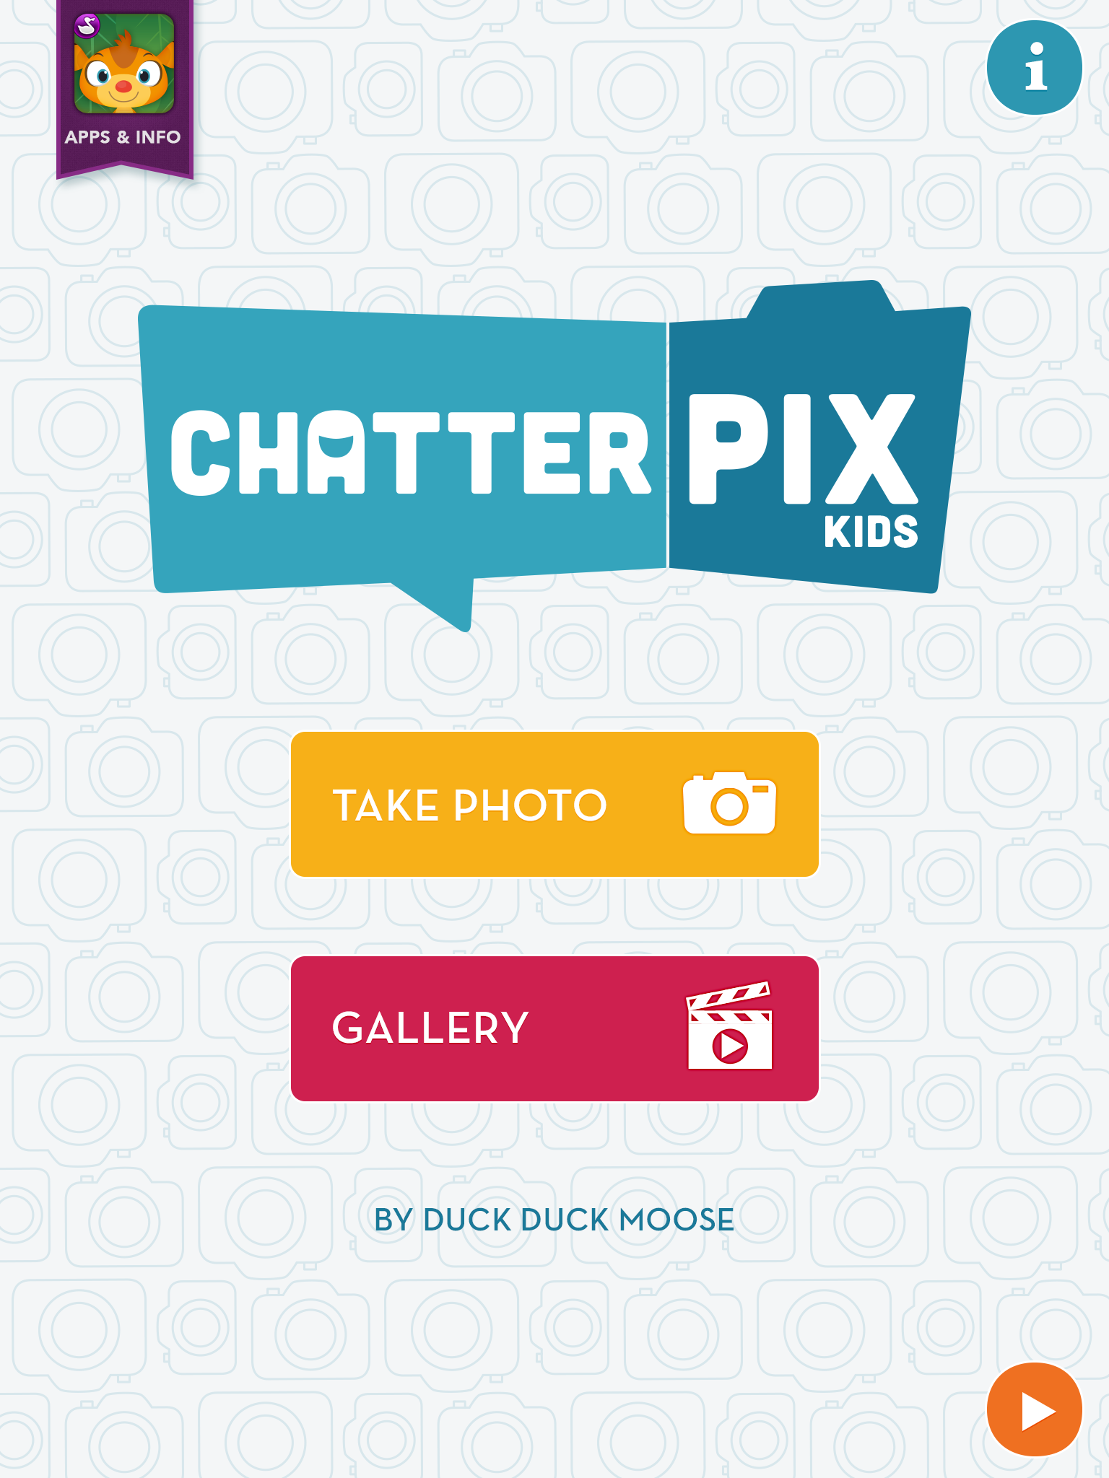

TAKE PHOTO Button – This button will launch the iPad camera. If you receive a message asking permission for Chatter Pix Kids to allow access to the camera and microphone, select yes.
GALLERY Button- This button will launch the gallery
of saved student work and examples created by
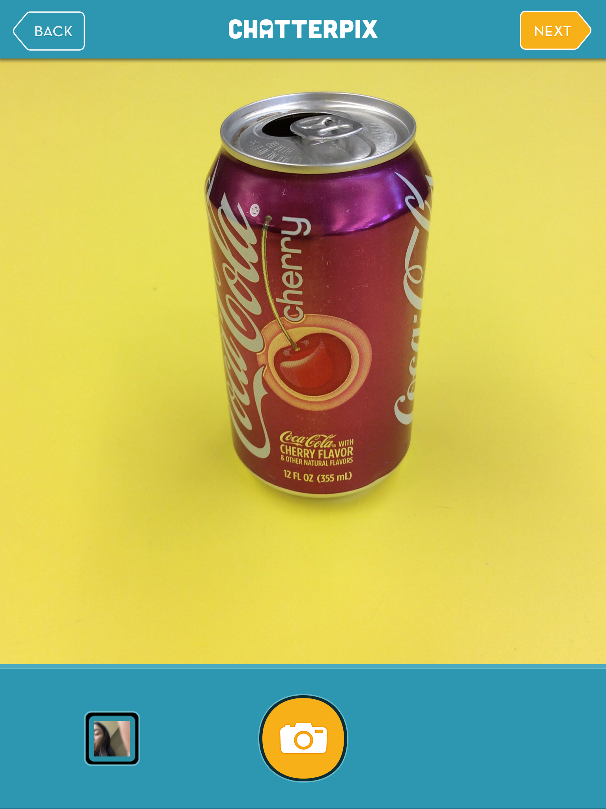
Chatter Pix Kids. It is possible to delete work in the
gallery.

Getting the right Photo
- Select the TAKE PHOTO button to take a photo.
Capture your subject by pressing the camera button.
I took a photo of a Cherry Coke can.
- Select the Camera Roll icon, on the bottom left,
to select a photo from the camera roll of saved
photos on the iPad.
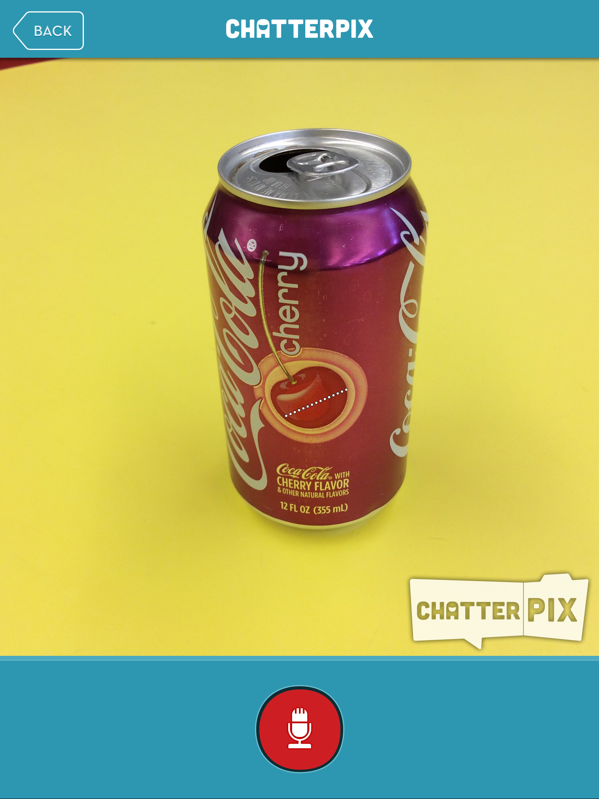
- Select the switch camera button to switch from the front facing and rear-facing camera.
- Press the orange next button, located at the top right of the app.

Recording Audio
- Draw the mouth- use your finger to draw a straight
line on one object. The line will become animated to
look like a mouth. If you make a mistake, just redraw
a different line over the picture.

- Press the red microphone button at the bottom of the app.
- You will see the count down from 3-2-1.
- Begin recording up to 30 seconds of audio.
- Press the microphone button again to stop recording.
- Press the green play button (triangle) to listen to the recording.
- If you would like to record again, simply press the red microphone button again and re-record your work.
- Once you are satisfied with the recording, press the orange next button at the top right of the app.

Extra Features
- The app has four extra features that can be applied to the recording.
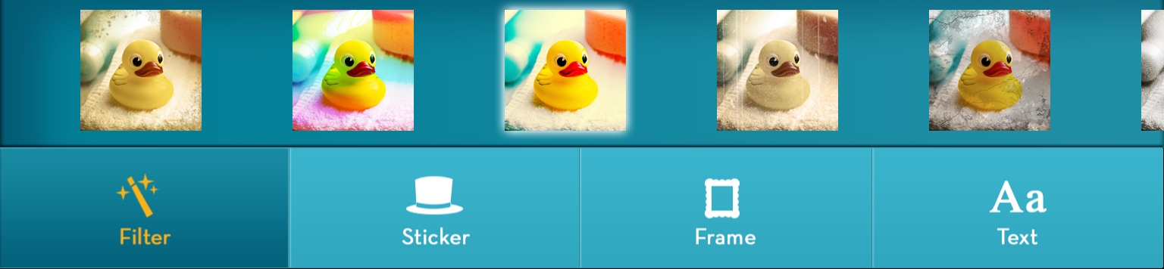
  - Filter-scroll across to view additional filters, tap the filter you would like to apply.

  - Sticker-scroll across to view additional stickers, tap the sticker you would like add to any photo.
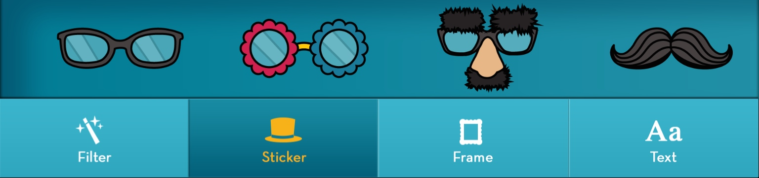

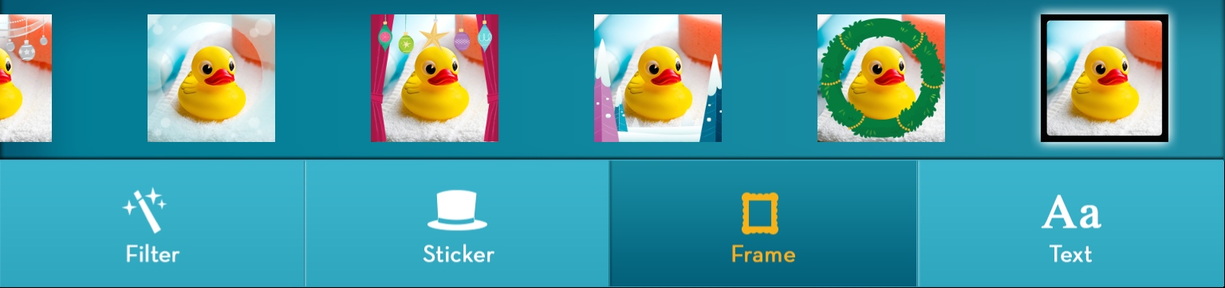
  - Frame- scroll across to view additional frames, tap the frame you would like to apply to any photo.

  - Text- scroll across to view additional text fonts, tap the font you would like to apply to any photo. Tap the text box, type your message and select a color, drag to the proper place. Use the Red trash can to drag any text or stickers you do not want to appear in the saved product.
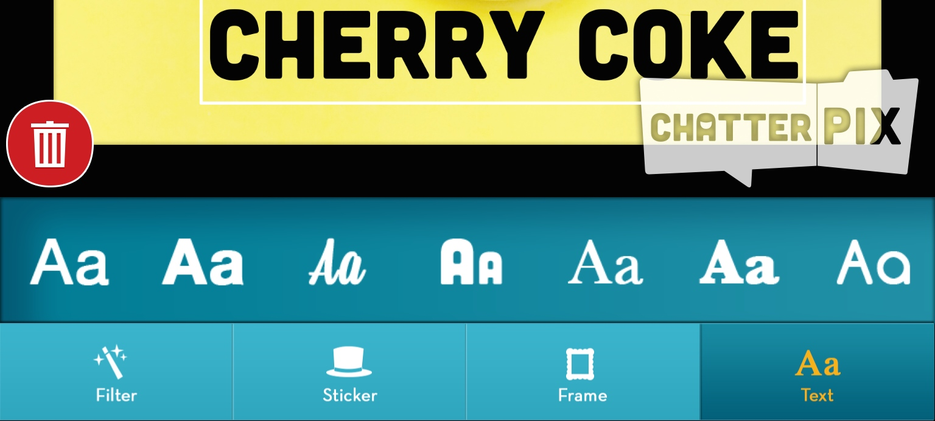

- Press the orange Next button on the top right of the app.
- Press the Green Play button to watch the final product.
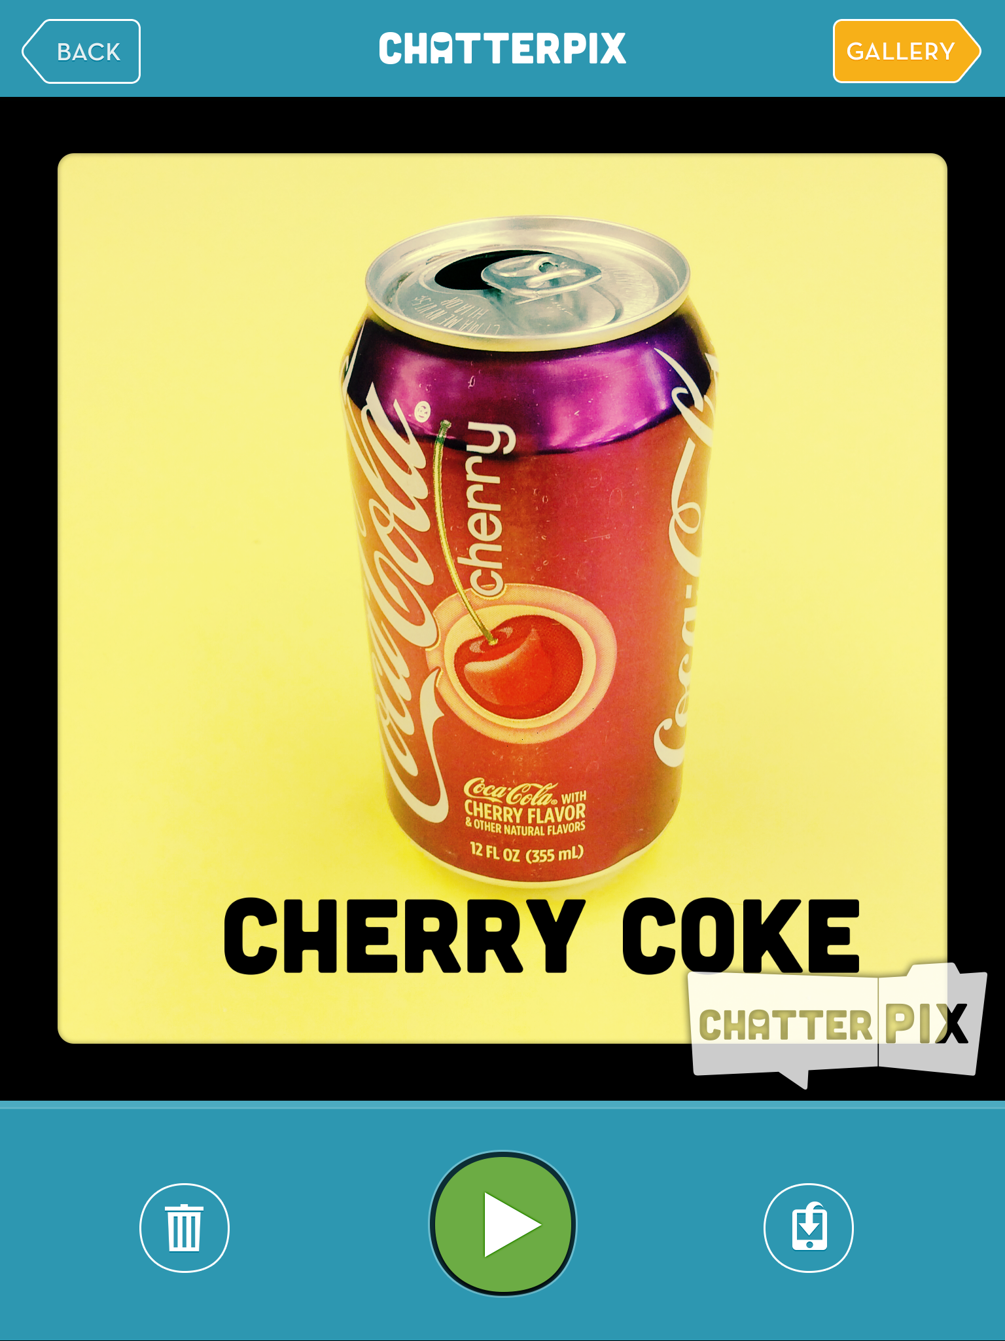
Saving and Exporting Student Work
- Press the Save Video button to save the video to the camera roll.
- Press the Trash Button to throw away the project.
Celebrate Student Work
- Share videos with the class.
- Post appropriate student work, with permission, to
the class website for parents and community members
to enjoy.
- Post appropriate student work, with permission, to a class
or student blog or wiki.

Resources
A Quick Intro Video
ChatterPix by Duck Duck Moose - Make Anything Talk!

Video Tutorial and Uses for the Classroom
What’s Appening - Chatter Pix Kids

