Popplet Lite
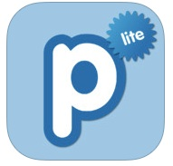

Vocabulary Work Station

Directions:
- Double tap the screen to create a bubble. Type or write the vocabulary word.
- Create a new bubble and draw a picture of the word.
- Create a new bubble and take a picture of the word.
- Create a new bubble and type the meaning of the word.
- Connect all bubbles to the vocabulary word.
- Create a bubble with your name on it.
- Export your work by selecting save JPEG.

